Counseling Center Electronic Forms – Case Management
You will be completing 4 electronic forms as pictured and described below:
Step 1: Using the UCI Student Health Patient Portal (http://osh.shs.uci.edu/), LOGIN with your UCInet ID and Password
Step 2: COMPLETE 4 FORMS

- To complete the 3 CONSENT FORMS:
- In the menu on the left – Click on (A) FORMS
- Click on Consent Form - Counseling Center Client Only
  - If you do not see the form, it means you have previously completed it
- Read the Counseling Center Information and Consent for Services Form. Check the box at the bottom of the page to acknowledge that you have read and understood this information.
- Type in your name and click on today’s date on the calendar
- Click Submit Final
- Click Proceed
- Repeat with Consent Form- Counseling Center – Telebehavioral Health and Consent Form- Counseling Center – Spring 2020 Notice to Clients
- DO NOT COMPLETE FORMS FOR OTHER DEPARTMENTS IN THIS SECTION.

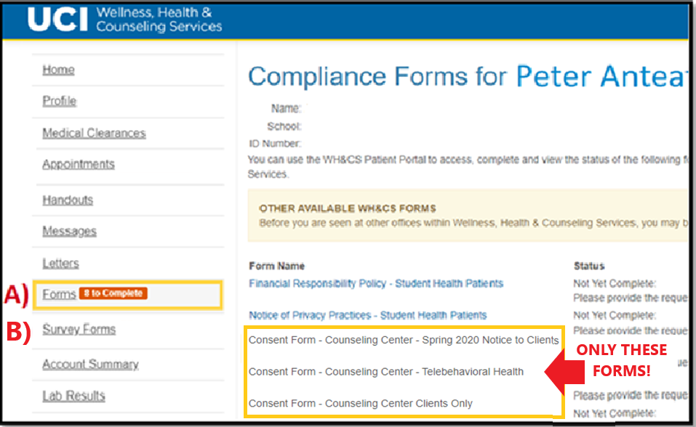

- To complete the SURVEY FORM:
  - In the menu on the left – Click on (B) SURVEY FORMS
  - Click on Telebehavioral Health Questionnaire
  - Complete the Survey
  - Click Finish
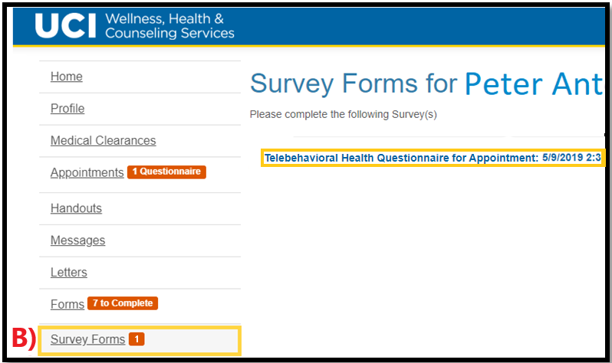

Step 3: Please LOGOUT (click on your name at the top right corner of the screen) and wait for your provider to begin the appointment via TAO (for video conference) or phone (from a blocked number)

Thank you!

