Counseling Center Electronic Forms – 1 Session Counseling
You will be completing 5 electronic forms as pictured and described below:
Step 1: Using the UCI Student Health Patient Portal (http://osh.chs.uci.edu/), LOGIN with your UCInet ID and Password
Step 2: COMPLETE 5 FORMS

- To complete the 3 CONSENT FORMS:
- In the menu on the left – Click on (A) FORMS
- Click on Consent Form - Counseling Center Client Only
  - If you do not see the form, it means you have previously completed it
- Read the Counseling Center Information and Consent for Services Form. Check the box at the bottom of the page to acknowledge that you have read and understood this information.
- Type in your name and click on today’s date on the calendar
- Click Submit Final
- Click Proceed
- Repeat with Consent Form- Counseling Center – Telebehavioral Health and Notice to Consumers – Counseling Center Clients Only
- DO NOT COMPLETE FORMS FOR OTHER DEPARTMENTS IN THIS SECTION.
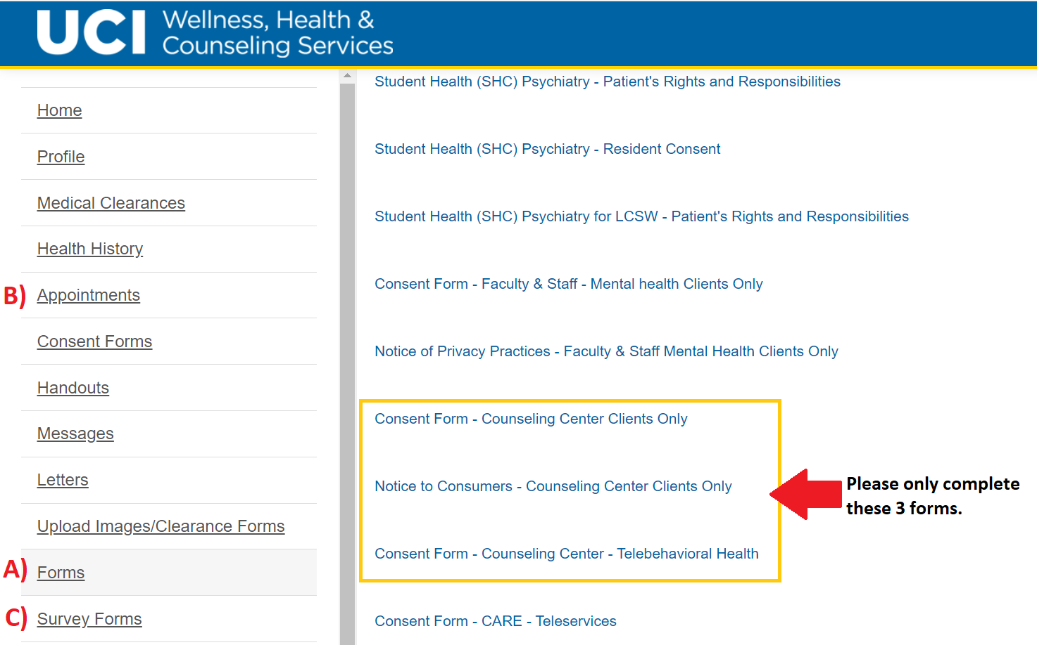
- To complete the CLINICAL QUESTIONNAIRE:
  - In the menu on the left – Click on (B) APPOINTMENTS
  - Click on “Complete Questionnaire” in blue under your scheduled appointment time
  - Complete the Clinical Questionnaire
  - Click Submit Final
  - Click Proceed
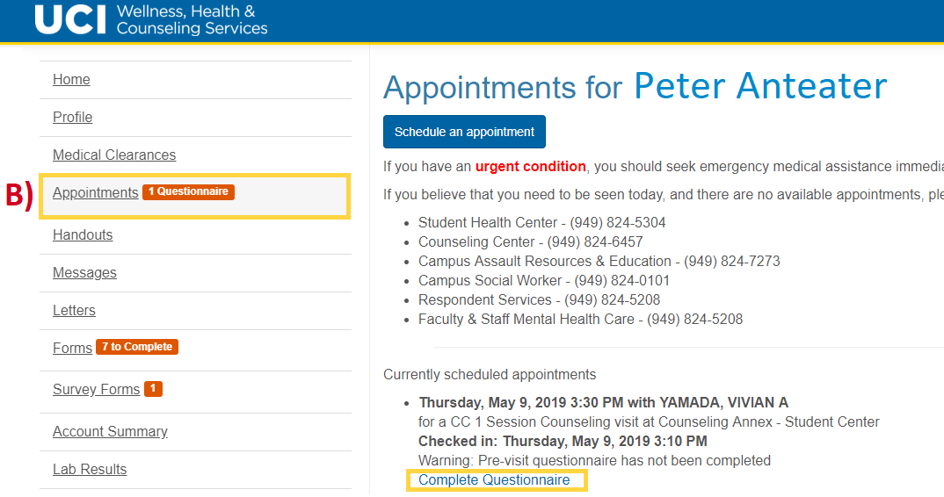
- To complete the SURVEY FORM:
  - In the menu on the left – Click on (C) SURVEY FORMS
  - Click on Telebehavioral Health Questionnaire
  - Complete the Survey
  - Click Finish
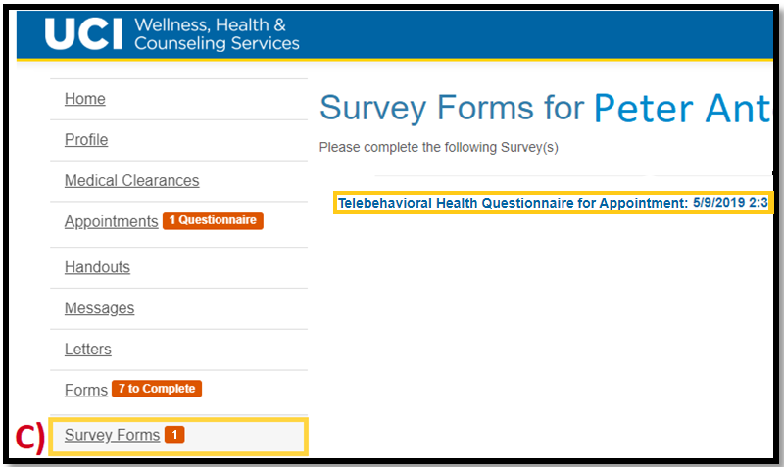
Step 3: To access your Zoom meeting, refresh the Appointments page and click, “Join Meeting”. If you are having a phone appointment, log out and expect a call from a private number.

Thank you!

