Counseling Center Electronic Forms - IA
You will be completing 6 electronic forms.
Step 1: Using the UCI Student Health Patient Portal (http://osh.chs.uci.edu/), LOGIN with your UCInet ID and Password.
Step 2: Click on ‘Appointments’.
Scroll down to ‘Currently Scheduled Appointments’, locate the correct appointment, and click on ‘Appointment Check In’.
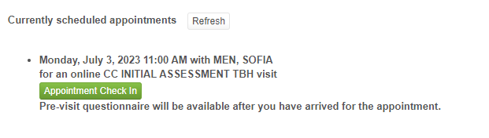Step 3: Update Contact Information.
You will be prompted to confirm your mobile phone number, local address, and permanent address. Click ‘Continue’ once you are ready to proceed to the forms.
Step 4: Compete the following 6 forms:
(The forms will automatically launch after clicking ‘Appointment Check In’.)
- CC Privacy Consent 2023
- CC Telehealth Con. 2023
- CC DCA Notice
- Student Questionnaire
- CC Counseling TBH Survey 23
- CCAPS-34
Step 5: Once you have completed and submitted all 6 forms, click on ‘Join Meeting’ to access the Zoom session. If the link does not appear, it can also be found near the bottom of the ‘Appointments’ page. If you have opted for a phone session, the provider will contact you from a private number at your scheduled appointment time.
**For additional assistance, call (949) 824-6457.

